**Computer Operations**

**What is Computer?**

An electronic device for storing and processing the data typically in binary form( in the form of 0 and 1)

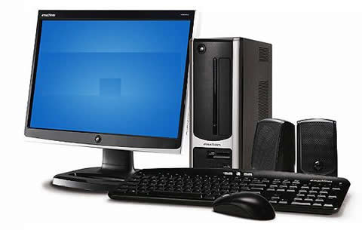 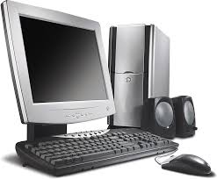

The Basic computer includes keyboard, Mouse, Monitor and CPU (central processing unit) .CPU(central processing unit) acts as a brain of computer . A computer CPU handles all instructions it receives from hardware of software.

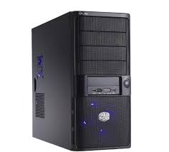 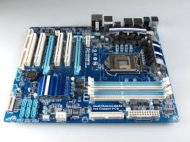

**Hardware: The** physical components of computer like monitor, CPU ,Mouse

**Software:**  it is collection of instructions that enables user to interact with computer and get response from the computer.

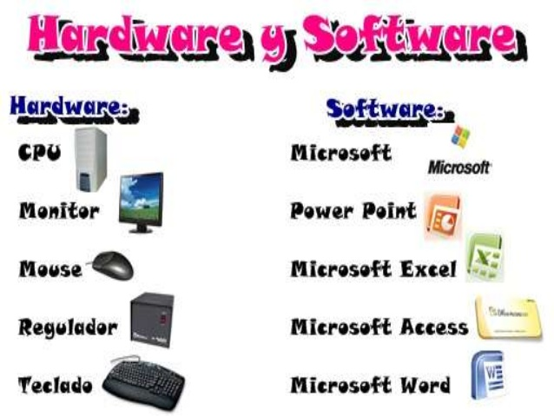

**An inside view of CPU (Central processing unit)**

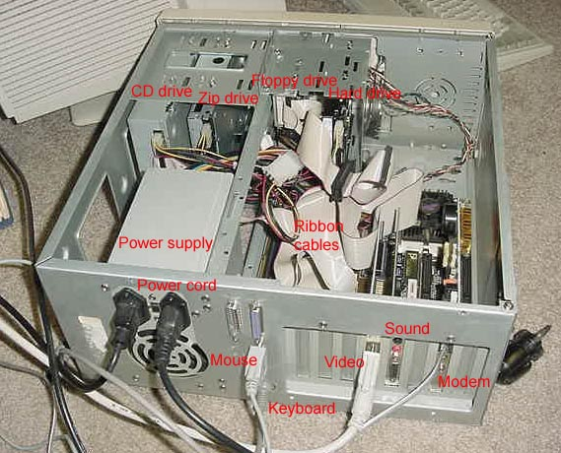

In order for a computer system to work it should have an operating system there are three most commonly used operating systems now a days .

1. Window Operating system

* Window 7
* Window 8,8.1
* Window 10

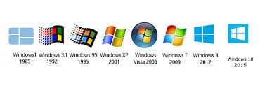

1. Macintosh OS( for Apple computers)

* MAC OS X

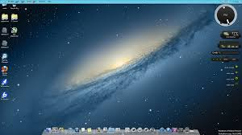

1. Linux Operating system

* Ubuntu
* Kali Linux
* Debian

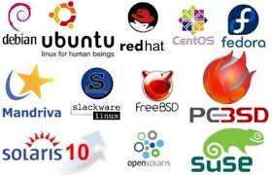

**User interfaces**

The mean by which a user and computer systems can interact, by using any particular software, input device or through set of commands.

There are two ways through which a user can interact with computers

1. Using GUI(Graphical user interface)
2. Using CLI(command line interface)

**GUI (Graphical user interface):** A Type of interface that allows users to interact with electronic device through Graphical icons and visuals indicators.

 

**Advantages of using GUI(graphical user interface)**

* Easy to use due to visual nature of the interface
* The user has lot of visual clues as to what things to do
* Less chance of user input errors
* Quicker to input commands

Disadvantages of using GUI (Graphical user interface)

* The display all the graphics required by GUI takes a lot of computing resources so quite powerful computing devices are needed.
* User is restricted to pre-determined options

**CLI(command line interface) :** Command line interface is sometimes referred as command line interpreter ,user console is a mean of interacting with computer systems.

* MS-DOS
* CMD
* Cisco CLI(Define their own set of rules that commands must follow)

**Advantages of CLI (Command line interface)**

* **The user has direct communication with the computer.**
* **Has wide range of commands to use and more complex operation can be perfomed.**

**Disadvantages of Using CLI(command line interface)**

* Need to learn number of complex commands
* Need to type commands (case sensitive) so there is possibility of errors
* 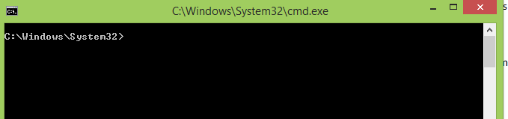Slow because having to type commands every time

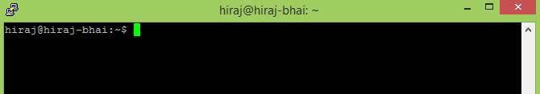

**IP (internet protocol) address**

IP (internet protocol address) specifies the location of host of client over the internet.

The IP address is also known as protocol address .IP address is Fascinating product of modern computer technology designed to allow one computer to communicate with another via Internet.

To find an IP address of computer following steps should be followed.

1. **Press window button and in search box enter “cmd.exe” without quote**

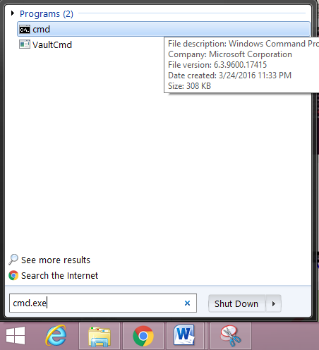

1. **Computer command prompt will appear on the screen**

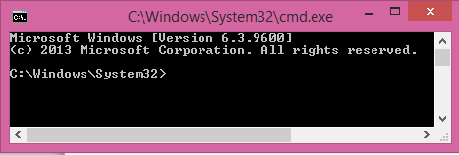

1. **In the command prompt enter “ipconfig” to check the IP address**

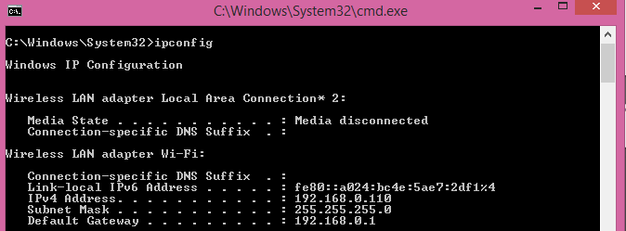

**At IPV4 row the IP address of machine is at line number nine (192.168.0.110).**

**Window commands to enable configuration**

1. **Ipconfig**

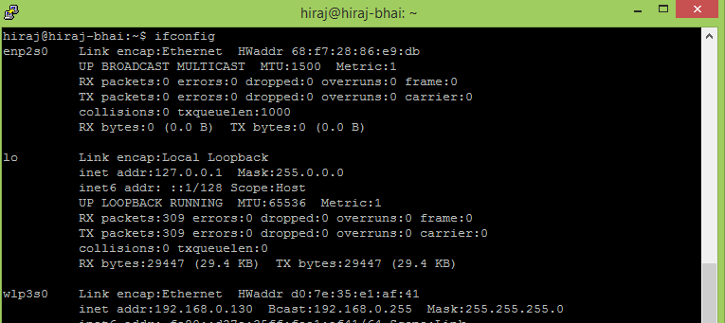The IP (internet Protocol) address of PC running window OS (operating system can be determined by using this commands) as shown above. And for the Linux based system ipconfig did not work so have to type “ ifconfig” instead of ipconfig.

**IP address can be seen at inet add: (192.168.0.130)**

1. **Ping, tracert command**

If you are experiencing issues connecting to website or other network connection issues. Windows and other operating systems have some standard tools to troubleshoot and identify error .Ping command is used to check the connection with any computer or website like Ping [www.google.com](http://www.google.com) will check either we have internet connection or not.

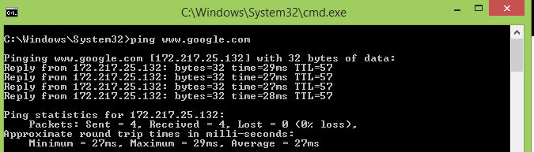If the system receives the reply form website or computer means connection is established. While Tracert command trace the route it takes for packets to reach the destination. For example to reach to Google server type the command “tracert [www.google.com](http://www.google.com)”

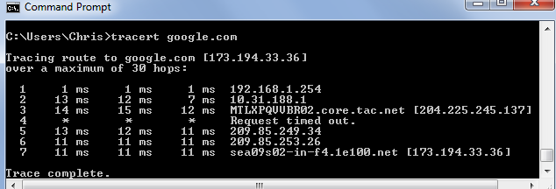

1. **Dir Command**

Dir command is used for file and directory listing in command line it specifies the content of that directory.

By using **dir *.txt** will display the listing of all .txt files.

By using my* will display all the files starting will the pattern defined like here “my”

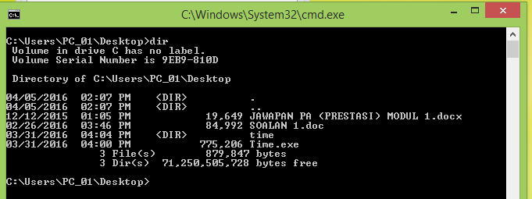

1. **Mkdir command**

Mkdir (Make directory) is a command that is used to make a directory (folder).

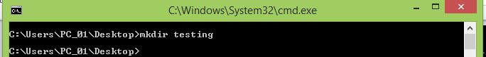

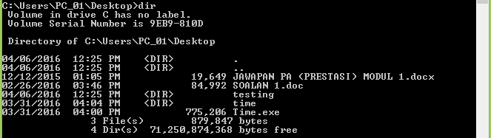To check either directory has been created again issue the command dir

1. **Rmdir**

This command is used to delete the directory .For example to delete the folder “testing” just issue the command Rmdir Testing it will delete the Testing folder.

If the Folder contains something then Rmdir can’t delete the folder for that we have to use rmdir/s “Name of folder” In this case Tesing

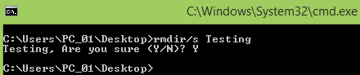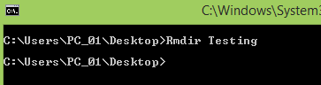

1. **Echo**

Echo command is used to print text on command line for example to print “Hello world” on command use the command echo ‘Hello world’.

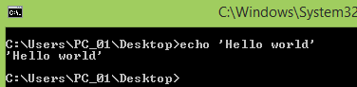

1. **Rename**

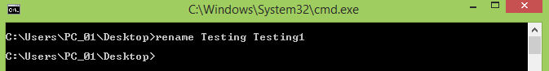This command is used to rename the name of directory using the command line like in this case to change the name of directory from Testing to Testing1 just enter the command Rename Tes

1. **Cd command**

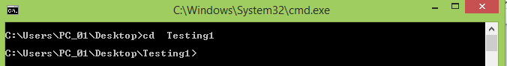Cd command is used to change current directory (the directory in which currently user is working) form the above example it can be observed current working directory is Desktop to change it to folder Testing1 that created enter cd Testing will change the working directory from Desktop to folder created . To exit that particular folder enters the command “cd ...” without quote.

1. Shutdown command

**This command is used to shutdown, restart from the command line as well as perform additional features.**

* **Shutdown/I Display the Graphical user interface to shut down your system or systems that are inside your network.**
* 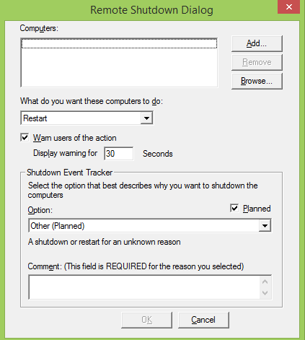This graphical interface can be used to remotely shut down the computers

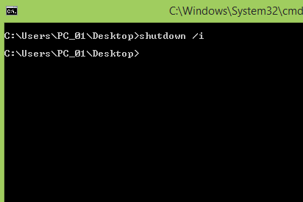

* **Shutdown/s** : it will shut down your computer
* **Shutdown/r :** it will restart the computer
* **Shutdown /h :** It will hibernate your computer

Quick Quiz

(1) Write down any three types of OS (operating systems)?

1. Window 10 OS
2. Ubuntu
3. Apple Pascal

(2) Which command is used to restart the computer from CMD(command prompt) ?

1. Shutdown /r
2. Shutdown /s
3. Shutdown /h
4. None of the above option

**Answer: shutdown /r**

(3) In command prompt which command is used to change the directory?

1. Cd
2. Ls
3. Dir
4. None of above

(4) Write down 4 basic networking command commonly used for troubleshooting ?

1. Ping
2. Tracert
3. Nslookup
4. Netstat

(5) Write down the difference between **ping** and **tracert?**

# Answer: Ping is used to check the layer3 connectivity while tracert is used to trace the path how data is travelling from one destination to another.

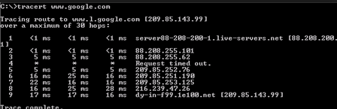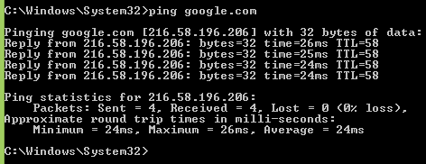

(6)  **What is difference between Mkdir and rmdir ?**

Answer:  **Mkdir is used to make directory while rmdir is used to delete the directory .**

**(7) Write down two advantages of using command line interface ?**

* Need to learn number of complex commands
* Need to type commands (case sensitive) so there is possibility of errors

(8) Which command is used to list down the directories in window based operating system ?

1. Dir
2. Ls
3. Netstat –l
4. None of above

**Answer: Dir**

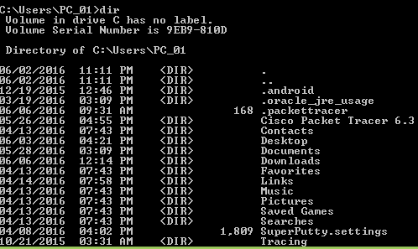

(9) Which command is used in Linux based operating system instead of “ipconfig” ?

1. Ipconfig
2. Ifconfig
3. Nslookup
4. Etho

**Answer : Ifconfig**